Two Roads Development and Alpha Blue Ventures Celebrate Groundbreaking on Forté Luxury Condominium in West Palm Beach
Over 80% of Forté’s 41 luxury residences have been sold

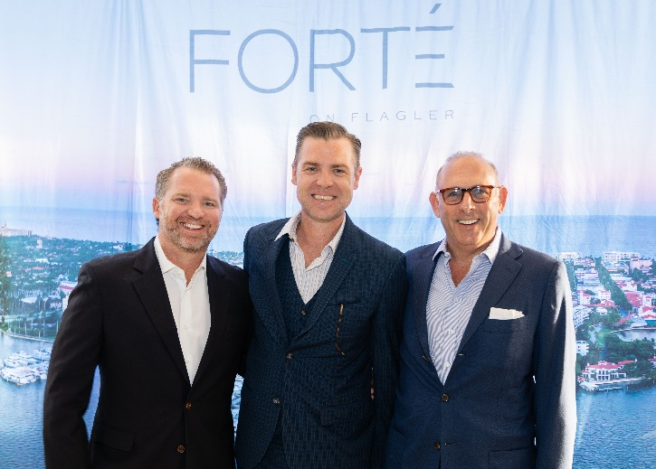
Pictured left to right: Two Roads Managing Partner Taylor Collins,
Forté Interior Designer Jean Louis Deniot and Two Roads Managing Partner Reid Boren

WEST PALM BEACH, FL – March 7, 2022 – Last Thursday evening, Two Roads Development and Alpha Blue Ventures celebrated the groundbreaking of Forté, a new waterfront luxury condominium at 1309 South Flagler Drive in West Palm Beach. The ceremonial event was attended by elected officials, community representatives and future residents, including Jean Louis-Deniot, Suzanne Ainslie, Michael and Meryl Mann, Judy and Jim Harpel, JoAnna and Steve Meyers, Robin and Reuben Jeffreys, Ken Haber, Cynthia Sulzberger and Steven Green, Chad Moss, Jay Parker, Myriam and David Leibowitz, and Caprice Webber. Over 80% of Forté’s 41 residences have sold, with majority of the buyers coming from markets across the domestic U.S. The 24-story boutique tower is on schedule to be completed in approximately three years.

"Our success at the groundbreaking is the direct result of the hard work and collaboration between the various teams working tirelessly to bring this project to life, from the creative minds and designers to the West Palm Beach community and real estate leaders," said Taylor Collins, managing partner of Two Roads Development. “The strong buyer market we’ve seen for Forté’s inspired design and breathtaking views is a testament to the value it offers to this community.”

“We’re celebrating more than a project milestone for Forté,” said Scott Maslin, founding partner and managing member of Alpha Blue Ventures. “As construction continues, we are watching Forté become a reality that delivers on the investment for buyers and for West Palm Beach.”

Editor’s Note: For high-resolution images from the Forté groundbreaking event please visit: https://bit.ly/ForteGB Photo courtesy of: Two Roads Development.

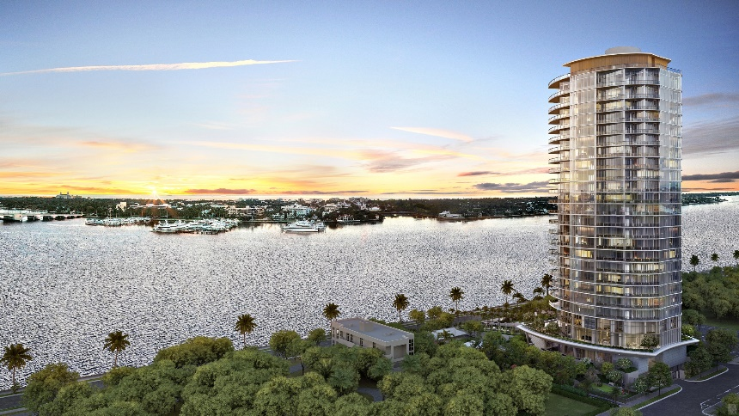

About Forté
Designed by Bernardo Fort-Brescia of Arquitectonica with interiors imagined by Jean-Louis Deniot, Forté’s sleek design will boast only two residences per floor, each with sweeping views of Worth Avenue, the Intracoastal Waterway and the Atlantic Ocean. Expansive three- and four-bedroom residences range from 4,200 to 8,400 square feet in size with the option to combine residences for a full-floor home. Forté’s six-bedroom penthouse spans 8,900 enclosed square feet with an additional 2,000-square-foot private rooftop deck which includes a pool, summer kitchen, cabana bath and unmatched 360-degree views.

Unit prices at the luxury tower range from about $7.38 million to more than $30 million. All residences will include private elevator foyers, at least 1,000 square feet of outdoor living space, no less than 10-foot-high ceilings, as well as Jean Louis-Deniot and Italkraft custom-designed kitchen and bathroom cabinetry with top-of-the-line finishes, fixtures and appliances from Sub-Zero, Wolf and Waterworks.

Among Forté’s standout amenities is an impressive second-story pool deck overlooking Palm Beach, complete with a 75-foot lap pool, heated spa and an outdoor dining and lounge area perfectly suited for hosting old friends and socializing with new neighbors. Designed to foster new levels of fitness, relaxation and rejuvenation, the third floor’s health and wellness spaces are equipped with a steam room, sauna, private treatment rooms, a relaxation area and locker facilities. These spa-inspired amenities are complemented by a state-of-the-art fitness center and yoga studio. Additional amenities include a private dining room with seating for up to 24 guests, a great room, a theater, an evening lounge, a card room and a multi-sport simulator. Two fully furnished guest suites are also available to create privacy for family and friends, while a business center offers all the office essentials residents might need for working remotely.

Resident services include 24-hour security and surveillance, 24-hour lobby attendant and valet service, access to the Forté’s house cars, as well as electric vehicle charging stations. An array of personalized concierge services include access to premium tickets and VIP events, restaurant reservations, moving coordination and storage solutions, interior design services, housekeeping services, spa and salon appointments, personal shopping, travel service with private and commercial air bookings, and in-residence wellness and fitness coordination.

Situated on storied South Flagler Drive, Forté rests within a tranquil residential neighborhood just south of the private Palm Beach Atlantic University campus. The Norton Museum of Art, Ann Norton Sculpture Gardens, and Antique Row Art & Design are all within proximity. The building’s central location gives residents convenient access to Palm Beach’s renowned social and cultural scenes, as well as several surrounding designer boutiques, jewelers, cafes and celebrity chef-driven restaurants.

Forté benefits from the track-record and expertise of a proven development team in South Florida-based Two Roads Development and Alpha Blue Ventures. Most recently, Two Roads Development delivered its latest luxury condominium to the market: Elysee, a 57-story waterfront tower in Miami’s Edgewater enclave.

For more information about Forté, including preconstruction sales opportunities, please call (561) 903-2819 or visit the project’s sales gallery at 1217 South Flagler Drive in West Palm Beach, FL 33401. Learn more at www.fortewpb.com.

*Editor’s Note: For high-resolution renderings of Forté, please visit: https://bit.ly/ForteMarch22
Photo courtesy of: Two Roads Development.

# # #

About Two Roads Development:
Two Roads Development is a South Florida-based real estate development firm whose principals have combined over 120 years of experience in developing, financing, and marketing residential and commercial projects across the United States. Over the years, Two Roads has set the standard for luxury development with properties that feature the best location, architecture, amenities, and services in the industry. The firm’s current residential portfolio includes Elysee Miami and Biscayne Beach, two luxury condominiums in downtown Miami, FL; Pendry Residences, a branded hotel and residential condominium in Tampa, FL; Forté, a 41-residence luxury waterfront condominium in West Palm Beach, FL; Tuscany Ranch, a 6,000-home master-planned active adult community in Citrus County, FL; and Freeport Plantation, a master-planned mixed-use community in Freeport, FL. Learn more at: www.tworoadsre.com.

About Alpha Blue Ventures:
Alpha Blue Ventures is a joint venture between founder Marius Fortelni, who provided Forté’s initial design inspiration, and managing partner Scott Maslin. The company specializes in the acquisition, development, and management of unique high-quality real estate projects throughout New York and Southeast Florida. Prior to Alpha Blue Ventures, Fortelni spent more
than 20 years building and operating a large multinational cement distribution and development company in Africa and Saudi Arabia and has developed several residential projects throughout the New York metropolitan area. Maslin is the founding member of Woodglen Investments, a New York-based real estate investment company that manages a diversified portfolio of real estate assets concentrated in New York and Florida. Learn more at www.alphablueventures.com.

